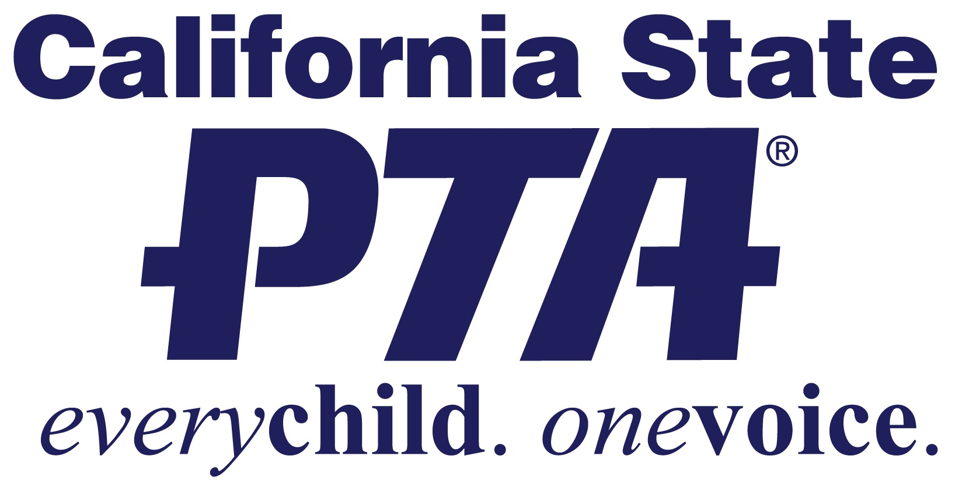

Local PTA Membership Goal Setting and Strategy Plan

SAMPLE GOAL SETTING WORKSHEET

Know where you are. Know where you want to go. Map your course—adjust as needed to reach your goal — Plug in your numbers

Where you are (have been)

In August 2020__________ PTA had ________ members.
In September 2020 ______ PTA had _________ members
In October 2020 ________ PTA had _________ members
In November 2020 ______ PTA had _________ members
In December 2020 ______ PTA had _________ members
In January 2021 ________ PTA had _________ members
In February 2021 _______ PTA had _________ members
In March 2021 _________ PTA had _________ members
In April 2021 ___________ PTA had_________ members
In May 2021___________ PTA had_________ members
In June 2021___________ PTA had _________ members

What is your goal (where do you want to go?) and what strategies will you use to achieve those goals? (How will you get there?)

MONTH BY MONTH GOALS AND STRATEGIES

Set your goals for the year, decide which strategies you will use and when—plug those in. Each month check your actual numbers against your goal and adjust your strategies if needed. Some strategies are included as examples, you will hear more at workshops and webinars, but brainstorm with your own committee and PTA board—you know your local community the best.

We will have_________ members in July 2021, an increase of______(% or #)
We will get these members by:

Which methods were the most successful? Notes:
______________________________________________________________________________________________________________________________________________________________________

We will have _____ members in August 2021, an increase of______(% or #)
We will get these members by:

Which methods were the most successful? Notes:
______________________________________________________________________________________________________________________________________________________________________

We will have _____ members in September 2021, an increase of______(% or #)
We will get these members by:

Which methods were the most successful? Notes:
______________________________________________________________________________________________________________________________________________________________________

We will have _____ members in October 2021, an increase of______(% or #)
We will get these members by

Which methods were the most successful? Notes:
______________________________________________________________________________________________________________________________________________________________________

We will have _____ members in November 2021, an increase of______(% or #)
We will get these members by

Which methods were the most successful? Notes:
______________________________________________________________________________________________________________________________________________________________________

We will have _____ members in December 2021, an increase of______(% or #)
We will get these members by

Which methods were the most successful? Notes:
______________________________________________________________________________________________________________________________________________________________________

We will have _____ members in January 2022, an increase of______(% or #)
We will get these members by

Which methods were the most successful? Notes:
______________________________________________________________________________________________________________________________________________________________________

We will have _____ members in February 2022, an increase of______(% or #)
We will get these members by

Which methods were the most successful? Notes:
______________________________________________________________________________________________________________________________________________________________________

We will have _____ members in March 2022, an increase of______(% or #)
We will get these members by

Which methods were the most successful? Notes:
______________________________________________________________________________________________________________________________________________________________________

We will have _____ members in April 2022, an increase of______(% or #)
We will get these members by

Which methods were the most successful? Notes:
______________________________________________________________________________________________________________________________________________________________________

We will have _____ members in May 2022, an increase of______(% or #)
We will get these members by

Which methods were the most successful? Notes:
______________________________________________________________________________________________________________________________________________________________________

We will have _____ members in June 2022, an increase of______(% or #)
We will get these members by

Which methods were the most successful? Notes:
_________________________________________________________________________________________________________________________________________________________________________________________________________________________________________________________

SOME STRATEGIES TO CONSIDER

- Sending an email to all current officers to remind them to join
- Talk to the principal about speaking at Back to School or orientation gathering
- Develop a letter asking parents and families to join PTA
- Recruit volunteers to sit at a PTA table for Back to School Events
- Send an email to last years members asking them to join
- Speaking at orientation and having a table to collect membership
- Speaking at teachers meeting about the importance of PTA
- Put up a bulletin board highlighting the programs PTA sponsors
- Ask the principal if Join PTA can be one of the messages on the school marque/electronic sign
- Have a PTA table at the front of the school the first week of school
- Launch the Back to school PTA membership contest (be inclusive)
- Recruit influencers to the membership team (committee)
- Speak to room parents/ASB/sports boosters

MEMBERSHIP COMMITTEE BRAINSTORMING WORKSHEET
Dealing with barriers:
What barriers stop people from joining PTA and what can you do to break that barrier down? ____________________________________________________________________________________________________________________________________________________________________________________________________________________________________
What works:
Ideas from other PTAs the committee like the most:
____________________________________________________________________________________________________________________________________________________________________________________________________________________________________
Specific monthly ideas:
What is successful in September is different from what is successful in January or March ____________________________________________________________________________________________________________________________________________________________________________________________________________________________________
Strategies for specific groups:
Kindergarten families/fifth grade families/ HS freshmen families/ASB
____________________________________________________________________________________________________________________________________________________________________________________________________________________________________

What works at high schools:
____________________________________________________________________________________________________________________________________________________________________________________________________________________________________

MEMBERSHIP RESOURCES

Membership Marketing:

http://capta.org/pta-leaders/run-your-pta/building-membership/

GETTING STARTED TARGET MESSAGING

Messages for Parents:
Highlight what the PTA does for students at the PTA school
________________________________________________________________________________________________________________________________________________________
____________________________________________________________________________

Messages for Teachers:
Highlight what the PTA does for students, teachers and the school AND Highlight that PTA as a statewide and National organization fights for education funding in Sacramento and also in Washington DC
____________________________________________________________________________________________________________________________________________________________________________________________________________________________________

Messages for Administrators:
Highlight what the PTA does for students, teachers and the school AND
Highlight that PTA advocates for education funding AND PTAs in California are all covered by a comprehensive insurance plan and have support in place if things go wrong.
____________________________________________________________________________________________________________________________________________________________________________________________________________________________________

Messages for specific groups:
Art clubs or art teachers—support for the arts—resources and reflections
____________________________________________________________________________________________________________________________________________________________________________________________________________________________________

Messages for community members:
____________________________________________________________________________________________________________________________________________________________________________________________________________________________________

Identify influencer (for each group):
____________________________________________________________________________________________________________________________________________________________________________________________________________________________________

Identify time location of message (for each group):
____________________________________________________________________________________________________________________________________________________________________________________________________________________________________

NUTS AND BOLTS OF PTA MEMBERSHIP

Why is PTA membership important?
What is the role of the membership team?

- Develop a membership campaign in conjunction with your membership committee and the school site administrator
- Develop a systematic way to encourage and collect membership
- Remit dues monthly—every MONTH
- Keep records—including a membership list
- Give a membership report
- Check your records against your council/district records

SAMPLE MEMBERSHIP REPORT

For the month of _____ we received ______ # of members this is _______ more than (less than) last year at this time. We are on track to meet our district goal of ______. (We need to step up our efforts to meet our district goal of____)

We have the following incentives/Awards/Contests:

California State PTA has the following incentives/Awards/Contests:

National PTA has the following incentives/Awards/Contests:

